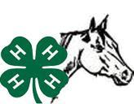
SANBORN COUNTY

4-H MEMBER’S ANNUAL REPORT
HORSE/RODEO PROJECT AREAS
4-H YEAR ______ to ______

Name ___________________________________________________________________________
Address__________________________________________________Zip ____________________
Date of Birth _____________________________ Age (on January 1 of current club year) _______
County _____Sanborn______________________
Years in 4-H Horse Project (include present year) __________
Parent’s/Guardian’s Name __________________________________________________________
My local club’s name is ____________________________________________________________

4-H Leaders _____________________________________________________________________
________________________________________________________________________________

My 4-H Horse Project Goals: Write your goals for this year. At the end of the year, tell how and if you accomplished those goals, or if not, why.

GOALS ACCOMPLISHMENTS
_______________________________________ ______________________________________
_______________________________________ ______________________________________
_______________________________________ ______________________________________
_______________________________________ ______________________________________
_______________________________________ ______________________________________
_______________________________________ ______________________________________
_______________________________________ ______________________________________

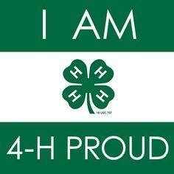

4-H Motto
“To Make the Best Better”

I Pledge My HEAD To clearer thinking.
My HEART To greater loyalty.
My HANDS To larger service, and
My HEALTH To better living, for My club,
My community My country, And my world.

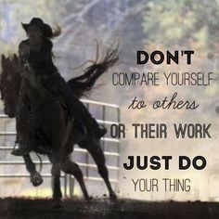
Participation in Activities

Name: ___________________________________ 20___ to 20___ 4-H Year

List activities in which you and your horse participated. Examples include shows, trail rides, clinics, camps, rodeos, etc.

Date | Activity | Location
Participation in Activities

Name: ___________________________________ 20___ to 20___ 4-H Year

List activities in which you and your horse participated. Examples include shows, trail rides, clinics, camps, rodeos, etc.

Date | Activity | Location
4-H record keeping is a life skill. Your 4-H record is an organized presentation of what you have learned and accomplished in 4-H. It is a useful tool for determining your own progress and personal growth.

Assembling Your 4-H Record Book

Assemble your 4-H record book in the following order:

Cover: Use a standard 4-H record book cover

Current 4-H Member’s Annual Report: A new 4-H Member’s Annual Report is completed each year.

Accumulative Record For Horse Activities: This is an ongoing accumulative record of your Accomplishments & Awards you have received. Every year you should update the record and bring it forward in your record book.

Your 4-H Story: The story may include:
    - What your 4-H Horse experiences have meant to you
    - What I did to keep my animal(s) healthy
    - Goals set and met/not met
    - Challenges/Problems encountered and how met
    - Results and what you learned
    - Other interesting or unusual activities about my animal(s)
    - Plans for next year

Photos: Tell your 4-H story with photos. Your photos should have captions and a date.

Clippings: Try to include clippings from the horse articles that are in the newspaper. Underline or highlight your name in the clippings.

YOUTH-IN-ACTION ACTIVITIES (such as Public Presentation, Judging, Fashion Revue, Special Foods, Showmanship)(Please add details of the following activities you did this year on the Accumulative Report sheets that follow this report).

________ Public Presentation ________ Special Foods

________ Judging ________ Showmanship

________ Fashion Revue ________ Awards received

YOUTH-IN-ACTION ACTIVITIES (such as Public Presentation, Judging, Fashion Revue, Special Foods, Showmanship)(Please add details of the following activities you did this year on the Accumulative Report sheets that follow this report).

________ Public Presentation ________ Special Foods

________ Judging ________ Showmanship

________ Fashion Revue ________ Awards received
Statement by 4-H Member

I have personally prepared this report and believe it to be correct.

Date: _________________ Signature of 4-H Member ___________________________________

Approval of this Report

Date: _________________ Signature _______________________________________________
Parent or Guardian

